Enhancing Nighttime Highway Drive Safety with a Raspberry Pi-Enabled Collision Alert System

Salna Joy1   
*Dept. of Electronics and Communication   
New Horizon College of Engineering   
Bangalore,India*  
salnamaryjoy@gmail.com

Vimarsha Rudresh4

*Dept. of Electronics and Communication   
New Horizon College of Engineering Bangalore,India*

Vimarsharudresh5736@gmail.com

R.Babychithra2

*Dept.of Electronics and*

*Communication*

*New Horizon College of Engineering*

*Bangalore,India*

chithra.nhce@gmail.com

Konduru Silpa5

*Dept. of Electronics and Communication   
New Horizon College of Engineering Bangalore,India*

rjraju0620@gmail.com

Chinagani Tharun Sai Yadav3

*Dept. of Electronics and Communication   
New Horizon College of Engineering Bangalore,India*

chinaganitharun@gmail.com

***Abstract*—Majority of incidents tend to happen during nighttime according to road accidents data. The proposed automated accident alert system presents an adaptable solution for the enhanced night drive safety on highways and remote areas, while attempts to lessen accident severity and improve outcomes with a focus on emergency response times. The system continuously monitor the dynamics of the vehicle and its surroundings, using a number of sensors, including an accelerometer, camera, vibration sensor, infrared sensor, alcohol sensor and a Raspberry Pi integrates the sensor outputs with GPS, GSM, LCD display, relay and buzzer.** **In order to identify driver fatigue, the system uses machine learning and eye-tracking algorithms. Through the timely issuance of alerts, the system seeks to prevent accidents. In case a collision is detected, the system quickly logs exact locations, ranks alarms according to how severe an impact is, and sounds a buzzer and relay to provide immediate notification. The LCD display offers feedback in real time. The system, which seamlessly integrates into current vehicle systems, attempts to lessen accident severity and improve outcomes with a focus on emergency response times.**

***Keywords: Road safety, Automated accident alarm system, Raspberry Pi, Sensor integration, Emergency response, Machine learning, Eye-tracking algorithm***

1. Introduction

Global road accident rates have increased recently; the World Health Organisation reports that 1.25 million people die in traffic accidents each year. In addition, accidents cause nonlethal injuries to 20–50 million people annually, with low- to moderate-income nations accounting for 90% of these cases [1]. Many of these countries have much higher mortality rates than developed ones due to inadequate emergency services and medical standards, which results in huge economic losses. Several studies have demonstrated how critical quick emergency responses are to the survival rates after mishaps. For example, in China, inadequate and ineffective help was the cause of around two-thirds of road accident fatalities in 2016 [2-4].

Moreover, a significant proportion of injured individuals pass away at the scene of the accident or in the roughly 30-minute ride to a hospital. Dispatch time, response time, scene time, and transport time are the intervals of time between the incident and the patient's arrival at a hospital. There is a comparison of mortality rates in urban and rural areas during these stages. According to the data, early accident detection greatly shortens the time it takes for emergency services to respond, boosting the likelihood that victims would survive [5,6]. While suburban incidents or those involving a lone driver may have delays in informing authorities during the crucial "golden window period" for medical treatment, assistance from drivers, passengers, or spectators is frequently available in urban locations. This ultimately diminishes the survival rate[7,8].

The increased demand for cars has resulted in an increase in traffic risks and accidents, endangering the lives of many individuals. The situation is made worse by the dearth of excellent emergency facilities in our nation. The current study addresses this by introducing an automated alarm system intended for auto collisions. This system can quickly identify incidents and send vital information to the first aid centre in a matter of seconds. Geographical coordinates, the time of the incident, and the angle at which the car crash occurred are among the transmitted data[9-11].

Anytime might be an accident on the road, and they frequently result in dire circumstances that need for quick care. Highways often traverse sparsely populated regions, making it challenging to promptly address accidents and seek assistance, particularly in remote areas, especially during nighttime [12]. The Automated Vehicle Crash Alert" is our approach to this urgent problem. The suggested system significantly aids in mitigating the severity of injuries and reducing the fatality rate in such circumstances. With the use of Raspberry Pi technology, this creative idea seeks to improve road safety by instantly notifying authorities of car accidents. By automating the process of notifying authorities and emergency services in the case of a car crash, Accident Shield is a comprehensive emergency services notification system intended to improve road safety. Integrated hardware includes accelerometers, GPS modules, GSM modules, alcohol sensors, IR sensors, vibration sensors, an LCD display, relay, buzzer, and a power supply (battery) that are all part of the system that is based on its Raspberry Pi.

Python is used to execute the programming code.By automating the procedure of notifying emergency services in the case of a vehicle crash, Accident Shield acts as a preventative safety precaution. The system facilitates a prompt and efficient response to accidents by combining several sensors and communication modules, which may prevent fatalities and reduce injuries. Accident Shield is a strong and adaptable remedy for improving traffic safety since it combines hardware elements with Python programming. The pursuit of enhancing traffic safety and cutting down on accident reaction times is crucial in this day of rapid technology development. An innovative solution that uses advanced technology and smart programming to provide a proactive safety net on the roads is Accident Shield, an Automated Vehicle Crash Alert System.

Unfortunately, traffic accidents frequently result in considerable loss of life and property damage. The speed at which emergency services may be called in and sent to the scene is crucial in reducing the aftermath of accidents. The human element included in traditional accident reporting procedures might cause delays, particularly in remote locations or in poor visibility. This is addressed by Accident Shield [13].

Driver exhaustion has consistently been a primary factor in numerous accidents, arising from fatigue, monotonous road conditions, and adverse weather conditions. In this paper, a novel Raspberry Pi-based system that integrates advanced algorithms for drowsiness detection is introduced, addressing the crucial problem of road safety. Through the use of machine learning and eye-tracking technologies, the system actively monitors driver behavior to avert accidents that could be caused by fatigued driving, thereby improving road safety overall [14,15].

II. RELATED WORK

1. “IoT-Based Car Accident Prevention and Detection System with Smart Brake Control (Murshed & Chowdhury, 2023):” presents a strong system that prioritizes ongoing dependability and is dependent on a stable Internet of Things network. It aims for GPS integration, roadside data mining, and compatibility with all vehicles.
2. “Vehicle Accident Prevention using Raspberry Pi and IoT (Aravind Sampath & Vidhyapathi C., Oct-2023):” Following an accident, the system updates GPS data and turns off the motor when it detects strong vibrations. Potential false positives and the inability to differentiate accident vibrations from other strong movements are challenges.
3. “IoT-Based Intelligent System for Vehicle Accident Prevention (Vivek Kinage, Piyush Patil, Jan-2023):” This real-time system uses an Arduino, a MQ-3 sensor, an accelerometer, an infrared sensor, and a webcam to identify problems, generate alerts, and, when necessary, cut the fuel supply. Accuracy of the accelerometer, infrared sensor, and MQ-3 are crucial.
4. "Accident Alert System Using Pressure Sensing Device (Tirth Patel, Saurabh Patel, April 2023):" In order to effectively handle increased traffic hazards, this system uses GPS and GSM modules to generate accident alerts. Its efficacy is dependent on the coverage of mobile networks, which could jeopardize communication in places with weak signals.
5. "Accident Detection and Alert System Using GPS & GSM on IoT-Based (Mar-2023):" By utilizing driver authentication, cloud storage, website accessibility, and real-time vehicle monitoring, the Automotive Monitoring Black-Box system improves accident prevention. But gathering and keeping sensitive data gives rise to privacy and data security issues.
6. "Drowsy Driver Detection with Crash Alert Mechanism (June-2023):" Integrating MPU-6050, GPS, and GSM, this system uses machine learning and Arduino Ide to detect and notify authorities about vehicular crashes, providing precise information for emergency services.
7. "Accident Alert System of Vehicle and Life Security using IoT Devices and Image Processing (Jan-2023):" This model uses an Arduino Nano, GPS, and GSM to send accurate accident notifications with audio calls and outdoor location accuracy. It has the potential to prevent auto theft and provide emergency services.
8. "Design and Simulation of a GSM, Buzzer, and GPS Module-Based Accident Detection (June-2023):" This technique improves accident detection in rural areas by utilizing an accelerometer, vibration sensor, Arduino Ide, and Proteus. With its affordable alert systems, the GPS tracker can potentially prevent accidents by facilitating quick emergency responses.
9. "Accident Detection using Automotive Smart Black-Box Monitoring System (Sep-2023):" This system enhances accident analysis and prevention by integrating DHT 111, MQ-2, TSSP53038, SW-18010p sensors, Arduino Ide, Zigbee, and Blackbox. It also ensures driver authentication, real-time vehicle monitoring, cloud storage, and website accessibility.
10. "Accident Detection and Alert System using GPS & GSM on IoT-Based (Mar-2023):" This smart vehicle system reduces road accidents, improves safety, and makes use of accelerometer, ultrasonic sensor, and alcohol sensor with Arduino Ide. Additionally, it offers safe parking and assistance to car owners.

III.PROPOSED SYSTEM

The system continuously monitor the dynamics of the vehicle and its surroundings, using a number of sensors, including an accelerometer, camera, vibration sensor, infrared sensor, alcohol sensor and a Raspberry Pi integrates the sensor outputs with GPS, GSM, LCD display, relay and buzzer. In order to identify driver fatigue, the system uses machine learning and eye-tracking algorithms. Through the timely issuance of alerts, the system seeks to prevent accidents. Based on preset parameters like abrupt acceleration, impact force, vibration patterns, and infrared signatures suggestive of a collision, the system uses this data to identify a vehicle crash. The GSM module is triggered by the system to send an alert that includes information about the crash, including its location, date, and time. This alert is sent by SMS or phone call to predefined emergency contacts. In order to bring attention to the situation, the buzzer sounds an alert and the LCD display simultaneously displays visual feedback regarding the crash. In case a collision is detected, the system quickly logs exact locations, ranks alarms according to how severe an impact is, and sounds a buzzer and relay to provide immediate notification.

Relays are used in power management to effectively control power to particular components, saving energy when the system is not actively monitoring a crash. It is optional to log crash data for later analysis, which may include timestamps and sensor readings.

Fig 1.System Workflow

The hardware elements used are as follows:

* Raspberry Pi: This credit-card sized computer serves as the robot's brain, processing sensor data and controlling other components.
* Accelerometer (ADXL-335): A compact, low-power accelerometer sensor with three axes of acceleration measurement is called the ADXL-335. It is frequently used to detect motion, tilt, and acceleration in electronic projects and devices.
* GSM Module: This module sends text messages to the operator, providing real-time updates on any detected motion.
* GPS (Neo-6m): The widely used NEO-6M GPS (Global Positioning System) module is renowned for its dependability and small size., It is frequently used in location-based projects and navigation systems.
* Alcohol sensor: An electronic gadget used to identify vapors of alcohol in the atmosphere is called an alcohol sensor. It is frequently used in safety applications, like vehicle ignition interlock systems, and breathalyzer systems to measure alcohol content.
* IR Sensor: Infrared (IR) sensor, It is extensively employed in many different applications, such as robotics object detection, smartphones' proximity sensing, and security systems' motion detection.
* Vibration Sensor: Vibration sensors are widely used for monitoring and detecting vibrations in industrial machinery and structural systems. They are devices that detect mechanical oscillations and convert them into electrical signals.

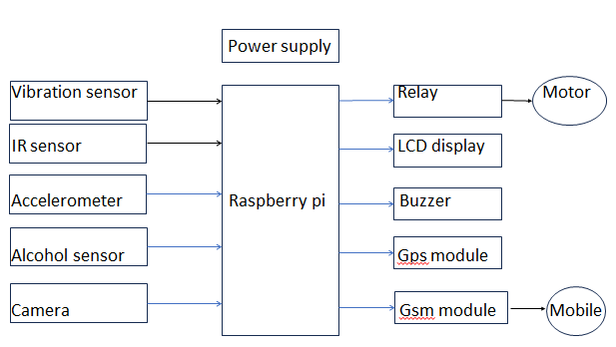

Fig 2. Block diagram.

The power (VCC) and ground (GND) pins of the accelerometer are connected to the corresponding power and ground on the main board. The accelerometer's output pin was connected to an analog input pin on the main board. The power and ground pins of the GPS module were connected to the main power supply, with the TX pin linked to the RX pin on the main board and vice versa. For the vibration sensor, its power and ground pins were connected to the main power supply and its output pin was connected to a digital input pin on the main board.

Similarly, the IR sensor's power and ground pins were connected to the main power supply, and its output pin was linked to a digital input pin on the main board. The alcohol sensor's power and ground pins were connected to the main power supply, and its output pin was connected to a digital input pin on the main board. In the case of the GSM module, its power and ground pins were linked to the main power supply, while the TX pin was connected to the RX pin on the main board and the RX pin was connected to the TX pin on the main board.

The buzzer was connected by attaching one leg to a digital output pin on the main board and the other leg to the ground. The power and ground pins of the LCD display were connected to the main power supply, while the data pins and control pins were linked to digital output pins on the main board. Finally, for the relays, their control pins were connected to digital output pins on the main board, and the power supply of components like GPS and GSM was connected to the common (COM) terminal of the relay, with the normally open (NO) terminal of the relay linked to the power supply.

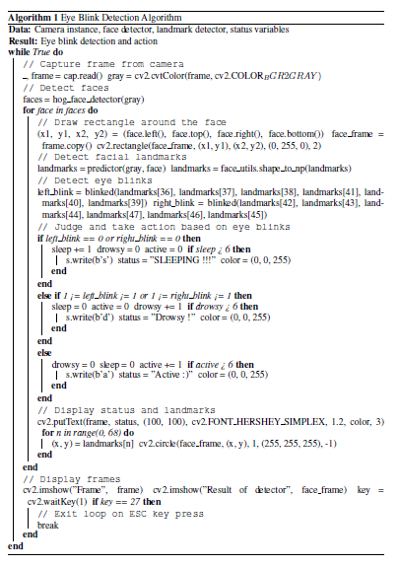

Fig 3. Drowsiness Detection Algorithm.

The Eye Blink Detection Algorithm uses facial landmark detection, face detection, and a camera to detect eye blinks. The OpenCV and Dlib libraries are used by the algorithm to detect faces and facial landmarks. Here's a step-by-step explanation of the algorithm:

1. Initialize all required variables, such as the camera instance, face detector, landmark detector, and status variables.
2. Enter a never-ending loop that keeps taking pictures with the camera.
3. In order to detect faces, convert the captured frame to grayscale.
4. The face detector can be used to find faces in the grayscale image.
5. Draw a rectangle around each face that has been detected before moving on to find facial landmarks.
6. Use the landmark detector to identify facial landmarks in the grayscale frame.
7. Take out the landmarks for the left and right eyes.
8. Analyze the distances between the eye landmarks to determine whether the eyes are closed, indicating a blink. Six landmark points are entered into the ‘bleanked’ function, which returns 1 when the eye is open and 0 when it is closed.
9. Based on the blink detection results, change the status variables to sleep, drowsy, and active. The user's state of activity, drowsiness, or sleep is ascertained using these variables.
10. The status and facial landmarks should be displayed on the frame.
11. If the user is asleep or drowsy, send the appropriate status to a serial port (s).
12. If you press the ESC key, the loop will be terminated.

The algorithm is intended to identify eye blinks and, based on the blink detection data, estimate the user's degree of drowsiness. The user's state is tracked by the status variables, and if necessary, the status data can be sent to another device via the serial port.

IV.RESULTS

The Autonomous Vehicle Crash Alert system that has been put into place, utilizing a Raspberry Pi and related parts, has demonstrated encouraging outcomes. The system for detecting crashes makes use of an accelerometer, vibration sensor, and infrared sensor to detect collisions. Precise reporting of crash sites is made possible by the GPS module's reliable and consistent location data. In order to guarantee a prompt response in a variety of network scenarios, the GSM module simultaneously and consistently sends alerts to pre-specified emergency contacts via SMS or calls.

The combination of audible alerts from the buzzer and visual feedback from the LCD display improves situational awareness for both the occupants of the vehicle and those in close proximity. The relay-equipped power management system exhibits effective energy conservation during periods of inactivity and maximizes continuous operation. An extra degree of security is added if an alcohol sensor is integrated since it can accurately identify the presence of alcohol.

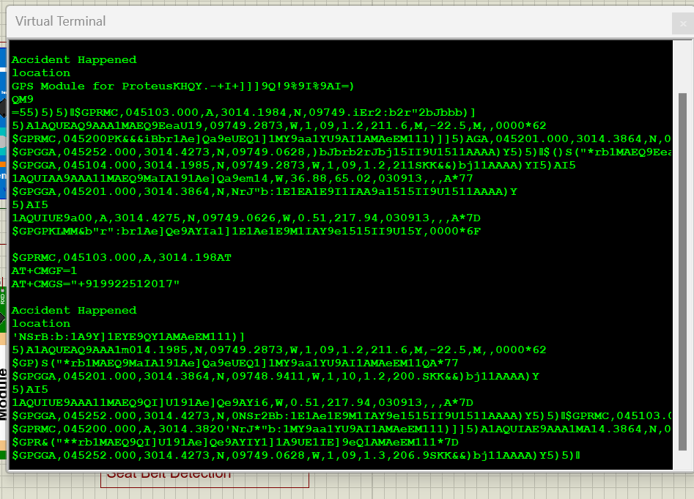

Fig 4. SMS from GPS & GSM modules.

Although more development and practical testing are necessary for thorough validation, the system's strong crash detection across a variety of scenarios highlights its potential. To improve usability, gathering user feedback is the next step. Working with emergency services to integrate the system and handle legal compliance is the next step to guarantee that the system complies with laws and protects user privacy.

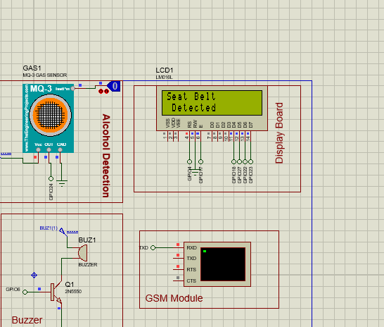

Fig 5. Seat Belt Detected.

Promising features include the Automated Vehicle Crash Alert system's strong crash detection and dependable communication capabilities. In order to improve the interface and address usability issues, user feedback is essential. Working together with emergency services guarantees a smooth transition into the current response mechanisms, which improves the overall efficacy of the system. Ensuring compliance with regulations and privacy standards is still a primary focus of legal compliance. It is imperative to conduct ongoing real-world testing to ensure thorough validation and identify any possible problems that might occur under different circumstances.

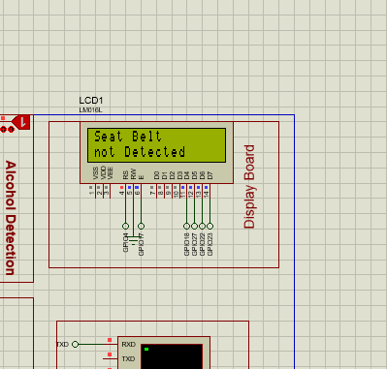

Fig 6.Seat Belt not-detected.

Promising features include the Automated Vehicle Crash Alert system's strong crash detection and dependable communication capabilities. In order to improve the interface and address usability issues, user feedback is essential. Working together with emergency services guarantees a smooth transition into the current response mechanisms, which improves the overall efficacy of the system. Ensuring compliance with regulations and privacy standards is still a primary focus of legal compliance. It is imperative to conduct ongoing real-world testing to ensure thorough validation and identify any possible problems that might occur under different circumstances.

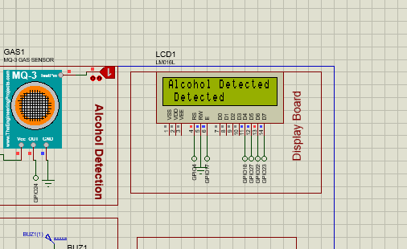

Fig 7. Alcohol Detection.

V.CONCLUSION AND FUTURE SCOPE

The Automated Vehicle Crash Alert systems’ conception and development represent a major advancement in emergency response systems and traffic safety. Highways often traverse sparsely populated regions, making it challenging to promptly address accidents and seek assistance, particularly in remote areas, especially during nighttime.

The suggested system significantly aids in mitigating the severity of injuries and reducing the fatality rate in such circumstances. This cutting-edge technology blends sophisticated hardware elements with astute programming to produce a complete solution. It is intended to autonomously detect and report accidents.

Further lane departure warning can be added to the system for enhanced safety. To sum up, the Accident Shield initiative, which uses technology to enable quick and automated reactions to car accidents, is a big step in the right direction towards increasing road safety. Adoption and successful deployment of such technologies could result in fewer injuries, save lives, and advance the creation of more adaptable and safe transportation networks.

V REFERENCE.

1. “Raspberry Pi Based Intelligent Road Accident Detection and Alert System " by P. Sathya Devi, K. Karthick Kumar, K.S. Ranjith, published in 2023 in the International Journal of Intelligent Systems and Applications (IJISA)”
2. "A Low-Cost Real-Time Accident Detection System for Vehicles Using Raspberry Pi and Machine Learning" by S.N. Deepak, N.S. Prajwal, R. Sreenath, published in 2023 in the Procedia Computer Science journal”.
3. Driver Drowsiness Detection and Automated Vehicle Control Using Raspberry Pi and Arduino" by D.V.S. Krishna, P. Manoj Kumar, K. Srikanth, published in 2023 in the Journal of King Saud University - Computer and Information Sciences.
4. Real-Time Road Accident Detection and Reporting System Using Raspberry Pi and IoT" by S.B. Patil, S.B. Patil, A.G. Kulkarni, published in 2023 in the International Journal of Advanced Science and Technology (IJAST).
5. A Novel Approach for Vehicle Accident Detection and Reporting Using Raspberry Pi and Cloud Computing" by M.M. Kulkarni, M.V. Deshpande, S.B. Patil, published in 2022 in the International Journal of Advanced Science and Technology (IJAST).
6. J. M, R. P, A. Kunjumon, M. Thamban and A. Roy, "Convolutional Neural Networks (CNN)-based Vehicle Crash Detection and Alert System," 2023 International Conference on Intelligent Data Communication Technologies and Internet of Things (IDCIoT), Bengaluru, India, 2023, pp. 161-164, doi: 10.1109/IDCIoT56793.2023.10053471.
7. M. V. CP, A. Manjunath, H. a. G, D. BT and S. G, "A Novel Vehicle Security System using Driver's License and Fingerprint Automation," 2023 International Conference on Innovative Data Communication Technologies and Application (ICIDCA), Uttarakhand, India, 2023, pp. 493-498, doi: 10.1109/ICIDCA56705.2023.10100168.
8. M. Karthik, L. Sreevidya, K. Vinodha, M. Thangaraj, G. Hemalatha, T. Viswak Sena,Automatic messaging system by detecting the road accidents for vehicle applications,Materials Today: Proceedings,Volume 80, Part 3,2023,Pages 3124-3128, ISSN 2214-7853, <https://doi.org/10.1016/j.matpr.2021.07.177>
9. Babu, A., Kavitha, T., Parameshachari, B. D., & Woźniak, M. (2023). HOPAV: Hybrid optimization-oriented path planning for non-connected and connected automated vehicles. IET Control Theory & Applications, 17(14), 1919-1929. <https://doi.org/10.1049/cth2.12441>
10. R. L. Paulraj, S. K. B V, G. V. Vardhan, K. S. Pradeep, K. Hemanth and G. B. Reddy, "A Detailed Approach on Vehicle Accident Recognition and Remote Alarm Device," 2022 International Conference on Advanced Computing Technologies and Applications (ICACTA), Coimbatore, India, 2022, pp. 1-5, doi: 10.1109/ICACTA54488.2022.9753270.
11. V. M. Deshmukh, R. B, G. B. Krishna and G. Rudrawar, "An Overview of Deep Learning Techniques for Autonomous Driving Vehicles," 2022 4th International Conference on Smart Systems and Inventive Technology (ICSSIT), Tirunelveli, India, 2022, pp. 979-983, doi: 10.1109/ICSSIT53264.2022.9716433.
12. Gunapriya Balan, Singaravelan Arumugam, Suresh Muthusamy, Hitesh Panchal, Hossam Kotb, Mohit Bajaj, Sherif S. M. Ghoneim, Kitmo, "An Improved Deep Learning-Based Technique for Driver Detection and Driver Assistance in Electric Vehicles with Better Performance", International Transactions on Electrical Energy Systems, vol. 2022, Article ID 8548172, 16 pages, 2022. <https://doi.org/10.1155/2022/8548172>
13. Balfaqih, M.; Alharbi, S.A.; Alzain, M.; Alqurashi, F.; Almilad, S. An Accident Detection and Classification System Using Internet of Things and Machine Learning towards Smart City. Sustainability 2022, 14, 210. <https://doi.org/10.3390/su14010210>
14. Alkhaiwani, A.H.; Alsamani, B.S. A Framework and IoT-Based Accident Detection System to Securely Report an Accident and the Driver’s Private Information. Sustainability 2023, 15, 8314. <https://doi.org/10.3390/su15108314>
15. dewopo, V.A., Elsayed, N., ElSayed, Z. et al. A review on action recognition for accident detection in smart city transportation systems. Journal of Electrical Systems and Inf Technol 10, 57 (2023). https://doi.org/10.1186/s43067-023-00124-y